January 22, 2017 Laura Silver, Jordyn Kosienski, Hannah Evans

Lawyer for Penn State, Esq

Re: Weather conditions at Jeffrey Field, State College PA (County of Centre) November 18, 2018; Justin Bieber v. Penn State

- Introduction and Data Sources
Justin Bieber filed a complaint alleging to have slipped and fell walking near Jeffrey Field on Penn State’s University Park campus due to a patch of ice on the sidewalk on November 18, 2018. He claims to have taken a nasty fall and snapped his vocal cords. Justin wants to sue the university for the millions of dollars he lost because of the fall. As a result, Penn State is inquiring about the weather conditions before and after the time of the incident.
During the course of our analysis, we have reviewed the following weather and climatological data.
- COOP data - State College, PA; November 18, 2018
- WeatherStem - Beaver Stadium, University Park, PA; November 18. 2018
- SC ACIS - State College, PA; November 18, 2018
- National Snow Analysis - State College, PA; November 18, 2018
- Wunderground - University Park Airport, State College, PA; November 18, 2018
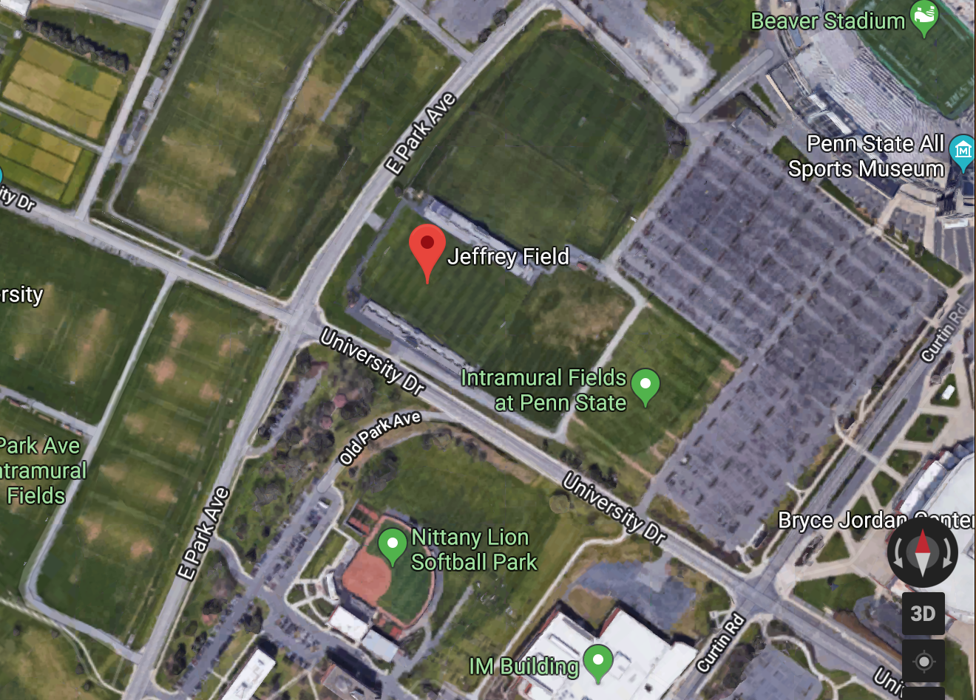
Location of Accident, Jeffrey Field, University Park PA
2. Summary of Weather Conditions on November 18, 2018
First, we took into consideration the observations recorded at the Walker Building COOP site on this day, which is about 1.5 miles from the accident site. The temperature at observation (7 am) was 34 degrees fahrenheit, with a high of 40 degrees fahrenheit for the day. To get a closer look at what the conditions were like at the accident site, we considered data from Weatherstem recorded at Beaver Stadium (0.3 miles from the accident site). The data shows temperature increased from 34 degrees Fahrenheit at 7 am to 38 degrees fahrenheit by noon, validating that the temperature was increasing further away from freezing point before/during the time of the fall. There was no precipitation recorded for the day but 4 inches of snow on the ground was recorded according to the COOP site. The rain gauge at Beaver Stadium courtesy of Weather Steam recorded no precipitation the night before or the morning of the fall. The COOP data at Walker Building shows there was a snowstorm two days prior on the 16, with a recorded 11.5 inches of snow which could account for the left over snow on the ground. The snow on the ground recorded at observation on the 17th was 7 inches, indicating 4.5 inches of snow had melted in the previous 24 hours. Since temperature stayed above freezing in the 24 hours prior to the fall, it is likely more snow could have melted. However, the time of the plaintiff's fall is unclear and so it is unknown the exact amount that had melted at that point.
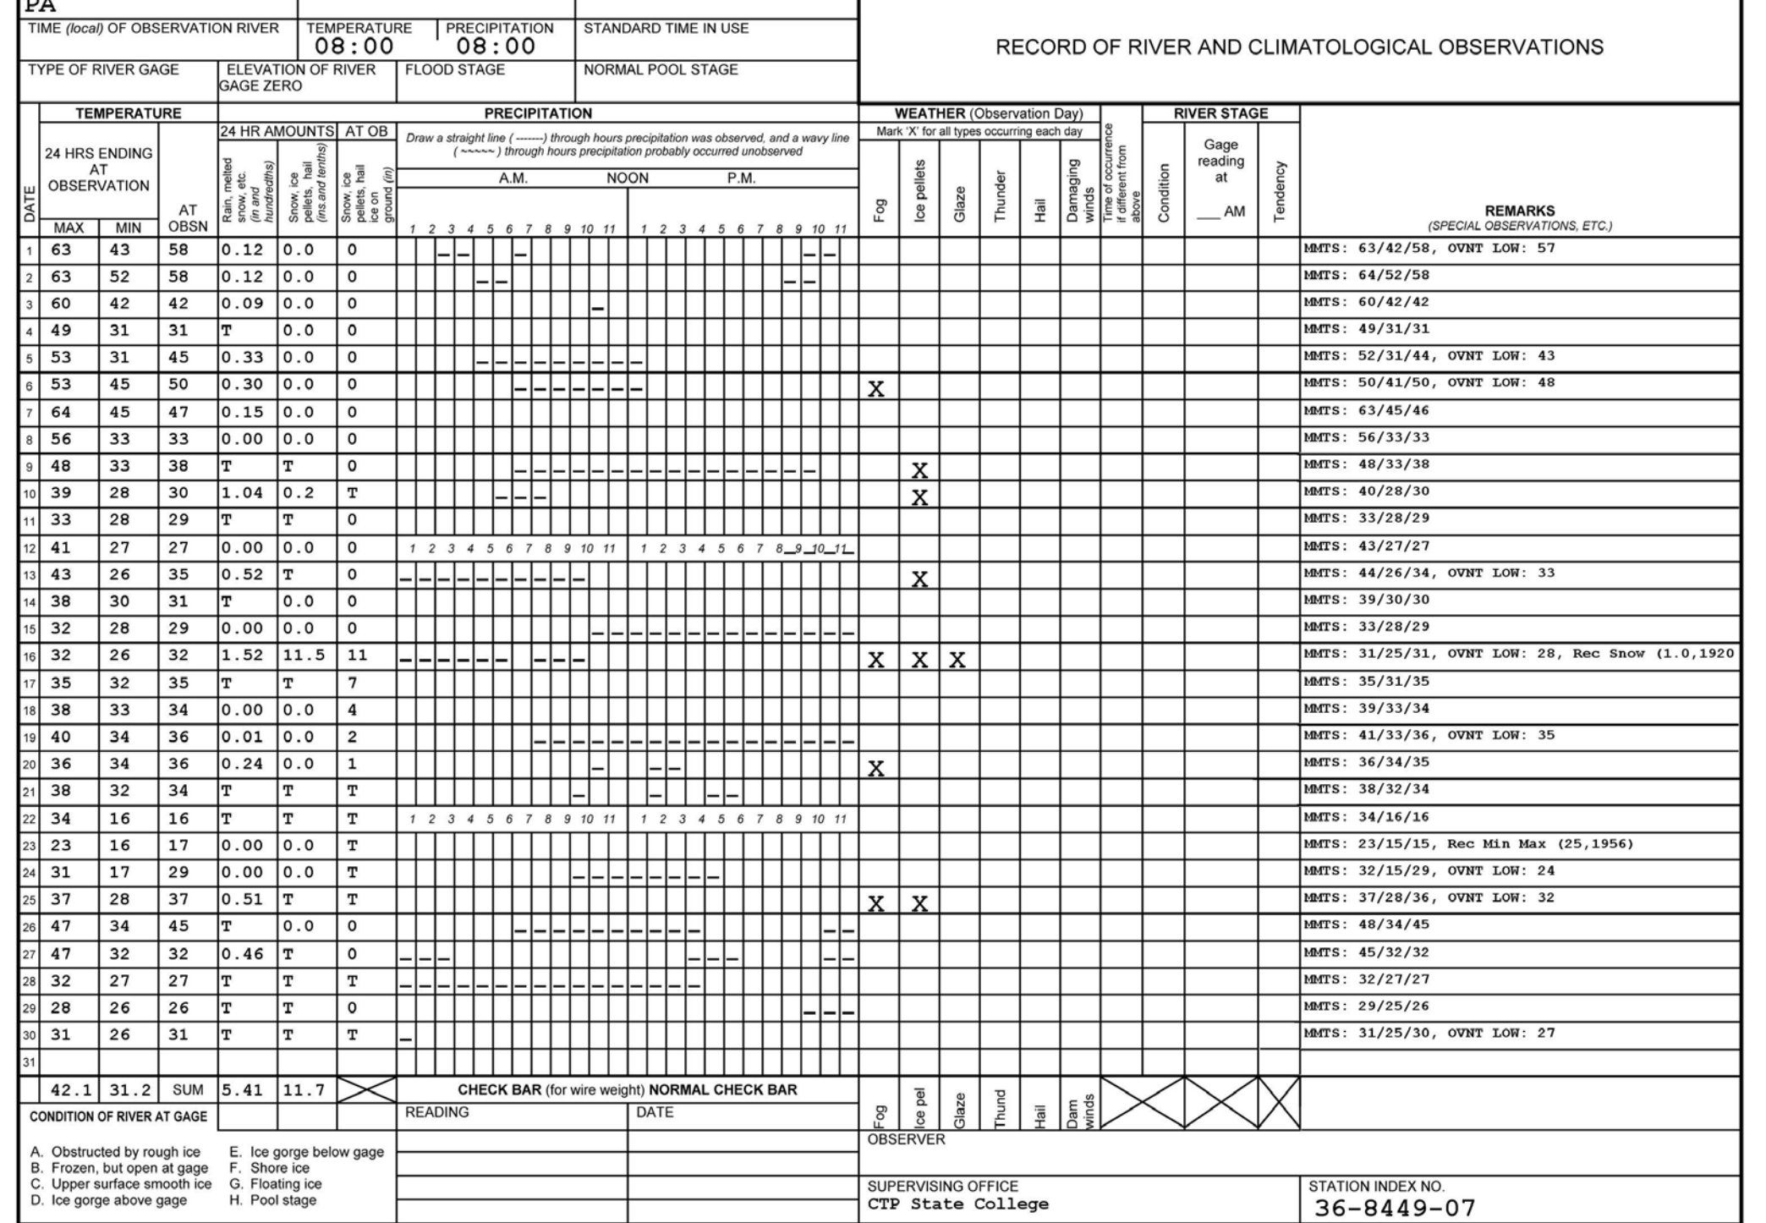
Another factor to take into consideration is the wind before the accident. The Beaver Stadium anemometer shows there was a wind gust of 11 mph at 11 am. Though it is unclear when the plaintiff fell, the wind could have blown into the sidewalk from a nearby snow pile and caused icy conditions. However, given that the temperature already rose to 37 degrees fahrenheit by this time, it is unlikely it would freeze into ice so quickly. SC ACIS also verified there was no precipitation on this day.
COOP Data for the month of November for Walker Building.
Zoomed in version of the COOP data for November 15-20, 2018

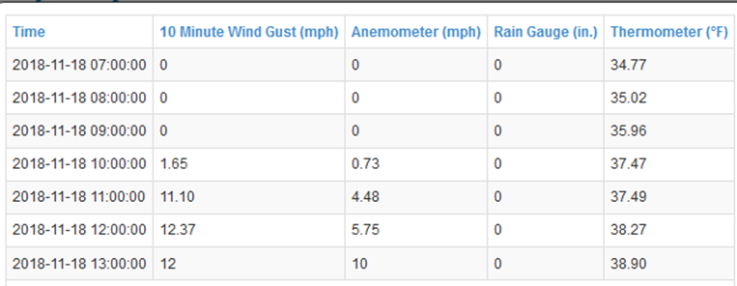
Data from WeatherStem taken at Beaver Stadium for 7 Am-1 PM on November 18,2018

The conditions on the previous night of the accident need to be considered in order to verify whether ice could have formed at the accident location. From the COOP site, we know that the low was 33 degrees fahrenheit, as well as there was around 4 inches of snow on the ground. Weatherstem verifies the temperature overnight stayed around 35 degrees fahrenheit, and went down to 34 degrees fahrenheit around 5 am, a few hours before the COOP observation. Therefore, the temperature was a few degrees above freezing, limiting the possibility of ice formation. Also, the anemometer at Beaver stadium shows the night wasn’t very windy, with the highest wind gust being 1.5 mph around 2 am. This indicates that it was unlikely snow blew from possible nearby snow piles onto the sidewalk. To verify no snow was blown prior/during the accident, we looked at a time lapse of blowing snow sublimation from the National Snow Analysis, which verified there was no snow blown in the region of the accident.
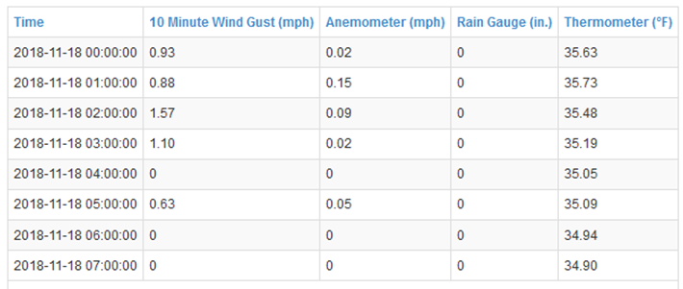
Data from WeatherStem taken at Beaver Stadium for 12-7 AM on November 18,2018

As another source to backup our data, we considered hourly observations at the University park airport from Wunderground. Though the airport is 4.5 miles from the accident site, the data observed here agreed with our data. It verified it was a calm day with temperatures climbing into the 40s. It also verified that no precipitation fell before or during the accident.

Hourly data taken at University Park airport for November 18, 2018

3. Data Limitations and Potential Errors
Some sources that we would of liked to of looked at, but were unable to due to the government shutdown were storm events data and NOAA radar data. This data would of helped confirm the weather conditions at the location of the accident.
Instruments that were used for this data include a thermometer, rain gauge, and an anemometer. Measurement errors could have occurred in these instruments such as value and range errors. For the thermometer, errors can be measurement scattering, incorrect accuracy of numerical calculations and calculation constants, and resolution errors. Rain gauges have errors such as strong winds, the rain gauge being clogged, and measurement error. Since we observed that no strong wind occurred at this time, this could not of possibly been a source of error. Anemometers measure wind by rotating cups as the wind blows, making the rod spin. An error in this could be that the wind speed was under measured due to the anemometer only being able to measure a certain amount of wind. We know that this could not of been an error due to no strong winds being observed at this time.
Some potential errors that we found in this data could be that the COOP data comes from a site 1.5 miles away and the airport was 4.5 miles away which could show an inaccurate temperature due to this distance. Justin fell some time in the morning, but we were not given an exact time. This leaves room for what the temperature was at the time of the fall. Temperatures did not get below freezing the night before, so we assumed that there was no ice present. Since the temperature overnight and that morning was so close to freezing point, there is a possibility that there still could of been ice. We made a reasonable assumption that snow was not blown onto the sidewalk in the overnight hours, yet we cannot say that it was not kicked up onto the sidewalk by people walking by and froze.

4. Conclusions and Opinions
The temperature at the observation site was above freezing during the acclaimed range of time of incident, as well as in the hours prior to the incident. Observations were reported and evaluated using COOP data from the Walker building located on campus. The observation site was located approximately 1.5 miles away from location of incident. Although observation is a significant distance from reported incident, the environmental area of both the COOP site and the location of incident are in the same weather elements-- being in a rural area surrounded by a grass like terrain. We also verified the data with the Beaver Stadium site courtesy of WeatherStem, which was only 0.3 miles from the accident site and limited room for error. The high temperature recorded by the COOP site the day of the incident was 40 degrees Fahrenheit. Additionally, overnight observations at Beaver Stadium display no evidence of temperatures reaching below freezing before the day of the incident, with the recorded low being 33 degrees. Observations taken the at airport site (SC ACIS, Wunderground) were about 4.5 miles from the accident site but also located in a rural area. Thus, the airport and accident site would have similar conditions based on the region of location.
No precipitation fell on the day of the incident, or the evening proceeding. Although the distance between the COOP site is 1.5 miles away, with complete confidence, no snowfall was apparent at the accident location on the day of the incident. The rain gauge at Beaver Stadium verified no precipitation before or during the accident. Snow remnants were apparent from the previous snowfall, but it was not windy enough or cold enough to create icy conditions on the sidewalk. Even with previously snowy conditions a couple days before the recorded incident, it's very unlikely that icy conditions were present because the ground would have not been able to be cold enough to create the formation of ice.

