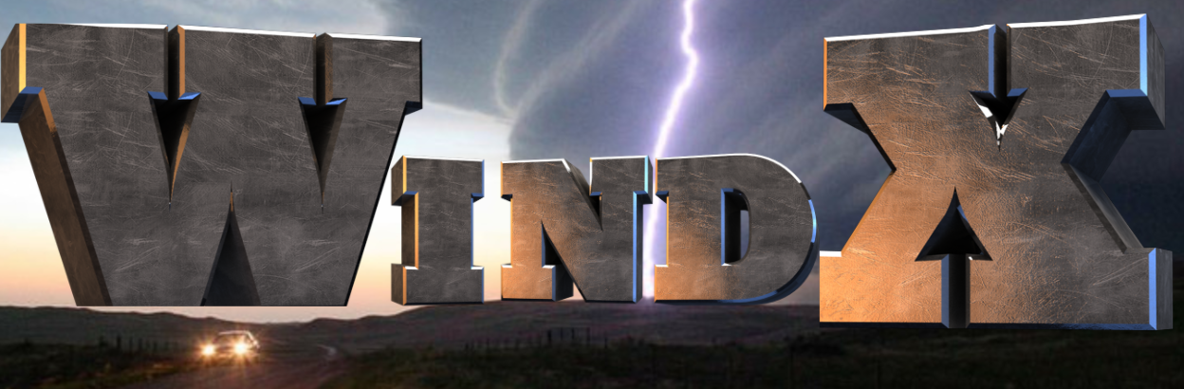
The Winning Weather Index

INTRO
Wind.X is a dedicated team of representatives driven to fulfill the Weis mission of creating the most inviting buying environment while saving consumers hard earned money and valuable time. Wind.X directly will fulfill this promise by strategically providing our Weis Weather digital program formulated specifically for the use of one store location geographically located in central Pennsylvania. Wind.X will provide a multitude of savings with its accurate weather forecasts that can be used to help understand fluctuation of products, sales, and revenue. Wind.X will also provide information that can be used to evaluate sales and revenue in multiple aspects of the company. Product sales, employee hours, delivery systems, and weather clean-up are just a few examples of how Wind.X is giving Weis the opportunity to save money.
Our dedicated team includes an individual representative that provides expert information in categories including industry, weather, programming, and managing. Laura Silver provides accurate weather information to benefit the company through predictions. Hannah Evans, our business and industries representative, accompanies Silver in resolving weather impacting business expenses, specifically focussing on Weis expenditures. Matt Yarosewick programs a platform using Evans and Silver’s weather and industry calculations to formulate a detailed program, Weis Weather, for the specific use of Weis markets. Our team of experts includes extensive amount of education in the meteorological field along with prior experience in business and programming. Collectively, our team has spent extensive amounts of time in understanding weather and all its formalities.

WEATHER
Weather can severely impact sales and business, which is why it is vital to prepare for the weather in advance. Given that the targeted store for our index is located in State College, Pennsylvania, the stores location will be subjected to winter weather. This is just one example of how weather can impact Weis stores. There are positive and negative impacts that come into play when dealing with weather.
When a big snowstorm is expected in the area, it is typically broadcasted over all forms of social media. As a result, people typically flock to their local grocery store to stock up on supplies. Being well aware of this type of weather can benefit Weis markets financially. With this knowledge, Weis will have the ability to know when they can stock up on supplies that will be in high demand, for example, products such as water and canned goods. Winter storms will cause higher demand of products and allow Weis to financially benefit from the storm from increased revenue. According to Weis’ 10K report, gross profit rate dropped from 27.8% in 2016 to 26.8% in 2017 due to lower than average winter sales volume from a lack of significant winter weather. This shows that having significantly bad weather can improve sales overall.
Winter weather can negatively impact sales as well. If storms are expected to be significantly hazardous, it would be smarter for Weis to close rather than end up having a loss in revenue. If blizzard like conditions or excessive amounts of snowfall are expected, businesses and schools will likely be closed. Because of significant storm conditions, people will stock up on goods before the storm, and stay home when the storm hits. If Weis were to remain open during a hazardous storm, they would pay more in employee salaries and additional costs that go into keeping the store open (electricity, heat, etc.) than the amount of revenue they would be making. This is why it is crucial to know when a store closing may be necessary.
Weis has been known to close before due to hazardous conditions. As stated on their site, there was a report in 2016 when Weis closed down due to a significant snow storm. The alert states “Due to the poor weather, most Weis Markets stores are closed today and will reopen on Sunday at 9AM. The list of closed locations includes all of our Maryland, New Jersey and West Virginia stores along with stores in and around Allentown, Bethlehem, Easton, Reading, the Delaware Valley, Chambersburg/Shippensburg, Hanover, York, Lancaster, Harrisburg, Selinsgrove/Sunbury/Lewisburg, Bloomsburg/Danville, State College/Altoona and the Poconos”. It is important to know what conditions warrant a closing, for Weis does not want to close when unnecessary and lose the chance of additional amounts of revenue.
Not only does weather impact sales, but it is a liability concern for the company during significant storm events. If Weis decides to keep their store open in hazardous weather, they risk employees traveling through bad weather. If an employee crashes on the way to work, they may push the blame on Weis for not closing down in regards to their safety. Another winter condition to consider is ice. When possible, Weis needs to have their sidewalks clear in order to avoid customers slipping and holding Weis liable. Therefore, if a storm does cause ice, it is important to be aware of refreezing overnight and wind conditions that could blow cleared snow back onto the sidewalks. If Weis is aware of such situations, they can treat their sidewalks and avoid any injuries that are related to slippery conditions.
Though winter weather will probably be of most concern for Weis stores, there are other factors to consider. Though rare in this area, hurricanes/ tropical storms have been known to hit this area in the past. As with winter storms, it is important to be prepared in the event one hits with supplies people may stock up on. If flooding with the hurricane is expected to be exceptionally bad, closing the store may be best in regards to minimal sales as well as employee safety. Being aware of torrential rain and flooding is important to Weis in regards to safety. Often times, older stores are prone to roofs leaking during heavy rains. If Weis is well aware of heavy rain, they can be prepared to have supplies such as wet floor signs and buckets on hand to avoid any injuries from shopping customers. Also, they will know to have an employee monitor the store in this situation and check for leaks. Though rare in this region, tornadoes are always a possibility. It is important that the store is aware when hazardous weather is possible in order to have a strategy for both their employees and customers during the significant storm event.
The level of preparedness needed for weather depends on what type of weather is actually about to affect the store location. To prepare for a winter storm, a 10-day forecast will be more efficient than a short-range forecast. This is because the store will need to know what types of supplies to stock up on in the case of a dangerous storm. However, weather this far out is subject to change, and so decisions such as shutting down the store should be determined on the day or previous day of the storm. Buying extra supplies of things like water and canned goods will not hurt the store, as these types of products are sold year-round and will be bought eventually. It will be better to have the supplies and not need them, rather than not have them and need them. Hurricanes/tropical storms also need to be known in advance, for Weis will have to stock up on supplies in this case as well. It will also expose valuable information for Weis to use by encouraging the store to have tools and equipment to board up their store and avoid damage from wind. Hurricanes and torrential rain, in general, are more useful when forecasted far in advance, for they could bring flooding to roadways and the store. In this case, it is better to be prepared to shut down for both the safety of the customers and the employees.
Short range forecasts (1-3 days out) will be more useful for other types of weather. Refreezing of snow overnight cannot be determined very well until the day before it happens, as it depends on winds and how much snow/ice actually fell. However, this will still be useful to Weis, as they can pretreat the sidewalks before the ice forms before employees leave. Given our store is open 24 hours, their will always be employees their to monitor the outside conditions of the store. Short range forecasts can also be useful in situations such as rainfall that is not significant enough to create flooding conditions. There isn’t much need to have a long-range forecast for medium amounts of rainfall, for example, the store roof may or may not leak, and it will be better to observe and treat the rainfall conditions as they come.
As meteorologists, it is important to know Weis can trust our forecasting knowledge. Weather data is constantly improving, and has so within the past decade. Processing power doubles every two years according to Moore’s law, and as a result models are constantly improving. Satellites are also getting better. The GOES-16 is a recent satellite creation that has 16 channels. Meteorologists have been able to use this to track things they never have before, such as lightning strikes.
As a result of better and more weather data overall, forecasts are improving along with the range of their accuracy. It is no secret the further out you go, the more error forecasts are subject to. However, as data improves, predictions can be more accurately determined for long range forecasts. In an article written by Seth Borenstein, an AP Science Writer, states, “Meteorologists are now as good with their five-day forecasts as they were with their three-day forecasts in 2005”. Given this article was written in 2017, forecasts have improved even from this in the past two years. It shows that forecasts are improving with time and that we can be trusted to give accurate weather data. 10-day forecasts will not always be 100% accurate, but they can still give a general idea on what to expect and be prepared for. .
Weis can trust our forecasts because data/model error is decreasing and forecasts are improving all the time. As mentioned above, technology is always improving, resulting in better models/data and thus, better forecasts. Pictured below is how forecast error for hurricane tracks have changed over time. As you can see, error has decreased each year and will continue to do so in years to come.

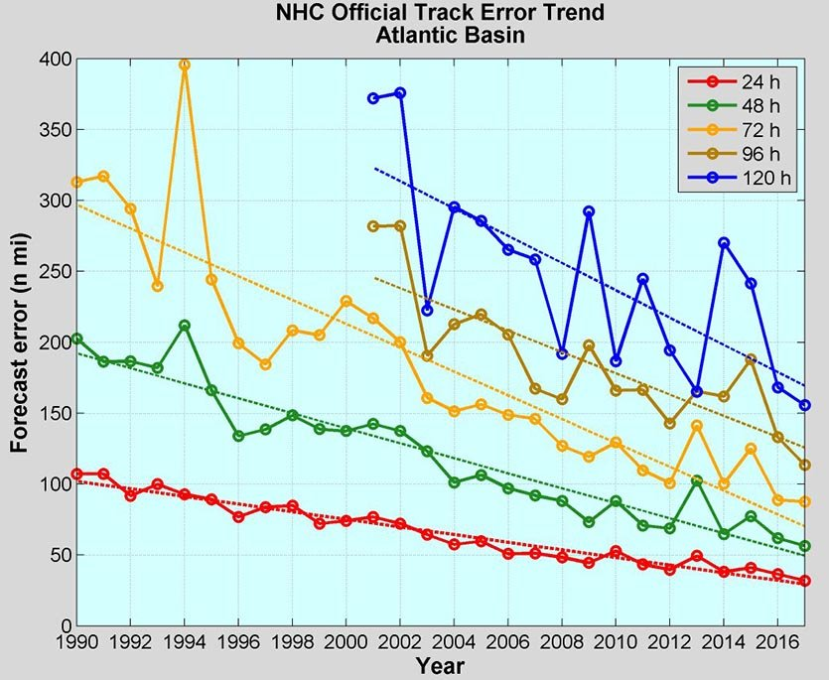
Hurricane forecasts are always improving. This graph depicts how error
Has decreased as time progresses (how off the forecast is in nautical
Miles to the actual forecast). This graph only goes to 2016, so error
Has decreased even more in the past three years and will keep
Decreasing.
https://www.google.com/search?q=forecast+error+improving&source=lnms&tbm=isch&sa=X&ved=0ahUKEwjckb3yyaDhAhWyt1kKHfLPD5YQ_AUIDygC&biw=1525&bih=710&dpr=0.9#imgrc=lgHy2DWtM8NjtM:

There are many studies that support the fact of improvement seen in forecasting. Another study shows that over the past three decades, forecast accuracy is increasing each year, which the image below depicts. The bold lines are forecasts for the northern hemisphere which is the area we are interested in. The graph shows that even 10 day forecasts are improving with time. This graph only shows to 2013, so the increase of forecast accuracy is even greater now, 6 years later.
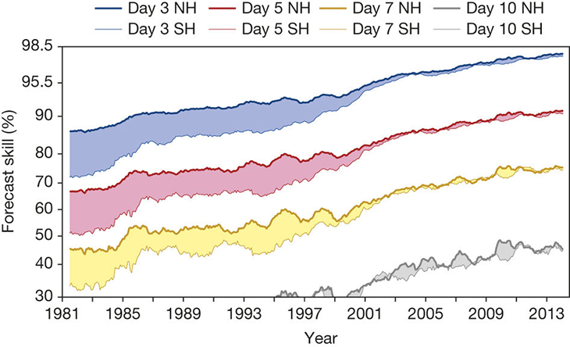
Forecast skill is improving as time goes on. The bold lines show the northern
hemisphere, our area of interest.

https://www.google.com/search?q=weather+forecasts+improving&source=lnms&tbm=isch&sa=X&ved=0ahUKEwi48aqn86DhAhWrVN8KHVHBC3UQ_AUIDygC&biw=1525&bih=710#imgrc=Zd9A8kIpHUF7RM:

These continuous upward trends in forecast accuracy is a result of the constant improvements in technology. More computer power allows for better models, and thus better data used for forecasts. Below is an example of how the ECMWF model has improved as a result of better computer power. Additionally, satellites themselves allow for better initial conditions that go into the models. Though the ECMWF is technically a european model, it is often used and can be trusted in predicting US weather. This is just one example of model improvements, for this model is not the only one that has improved in accuracy as a result of better technology.
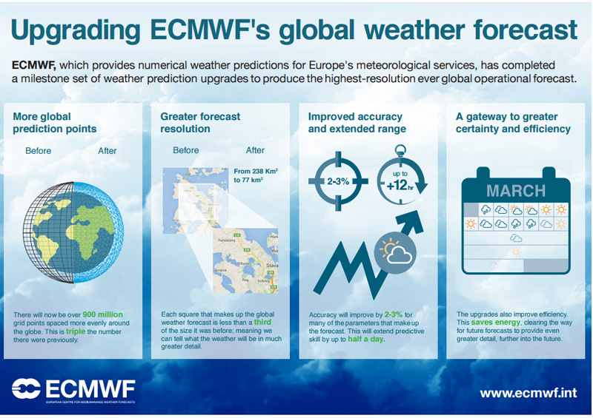
The ECMWF has experienced upgrades for more accurate forecasting thanks to improved technology
and computer power. This is a reason for why forecasts are always improving, as bettering models
provide more accurate data.
https://www.google.com/search?q=weather+forecasts+improving&source=lnms&tbm=isch&sa=X&ved=0ahUKEwi48aqn86DhAhWrVN8KHVHBC3UQ_AUIDygC&biw=1525&bih=710#imgrc=XhuJxBpRdLG4PM:

Though we can be trusted and forecasts are constantly improving, it is important to know there is still some uncertainty when predicting storms far in advance. Shown below is the cone of uncertainty for hurricanes. Even if a tropical storm is forecasted to hit in enough radius to cause damage to Weis, there is the chance it could change courses and not cause any damage at all. The cone increases in size the farther out you go with the forecast, showing that forecast error increases with time. However, it is better to be prepared in the case it does hit, rather than not be prepared at all. Hurricane forecasts are improving as shown above, and so this cone of uncertainty is becoming less of an issue as time goes on.
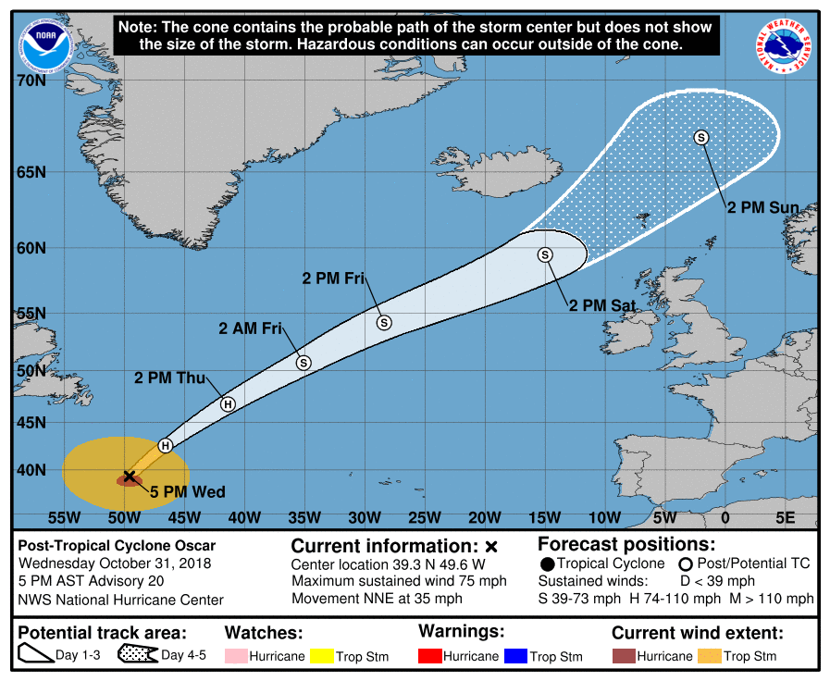
The cone of uncertainty associated with hurricanes. The
farther in time you go, the larger the cone becomes. This
shows that predicting a hurricane track is subjected to
larger error the farther out the forecast is.

https://www.google.com/search?q=noaa+cone+of+uncertainty&source=lnms&tbm=isch&sa=X&ved=0ahUKEwiwnrqWjJ7hAhUDh-AKHQIJBRsQ_AUIDigB&biw=865&bih=403#imgrc=Tz9S4vRbRnmu_M:

As with hurricanes, predicting winter storms in advance can cause some difficulty as well. Though predicting some type of storm will hit is typically accurate, it can be hard to be exact on what type and how much precipitation will actually fall. Factors such as surface temperature, atmosphere temperature, and the snow-liquid ratio can all affect what type of precipitation occurs and how much. Forecasting storms like these at least 7-10 days out is necessary in order for Weis to be able to prepare by stocking up on essential supplies. Therefore, there is the chance a snowstorm is expected to hit, yet its course or atmospheric conditions may change in that week’s time. Thus, the storm expected to hit may not, or may not be as eventful as originally thought. Once again, it is better though for Weis to prepare in the case it hits. Thus, there is room for error when predicting the weather 7-10 days or more in advance, but taking our advice will always allow for Weis to be prepared in the case impactful weather occurs. As mentioned before, forecasts are ever improving and the likelihood of us giving an inaccurate forecast is minimal as a result.
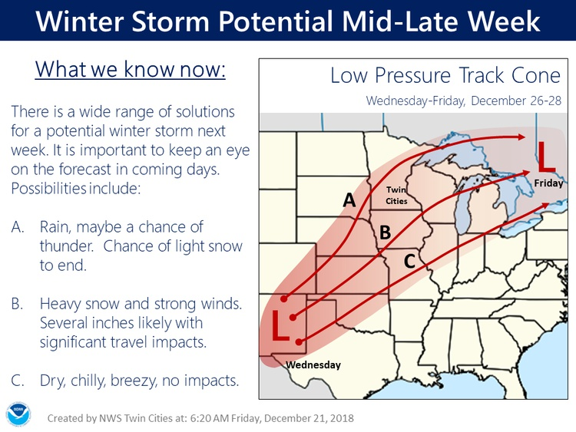
Picture is the track cone for low pressure systems.
This shows forecasting what track a low pressure
System that is expected to produce snow can
Change as it moves and affect a different region
than expected.
https://www.google.com/search?q=weather+uncertainty+winter+storms&source=lnms&tbm=isch&sa=X&ved=0ahUKEwi83p7T0Z7hAhVCNd8KHXVNBbIQ_AUIDygC&biw=1047&bih=488#imgdii=PMH9SjrQ3UYnHM:&imgrc=_SvO3m7dsVDteM:

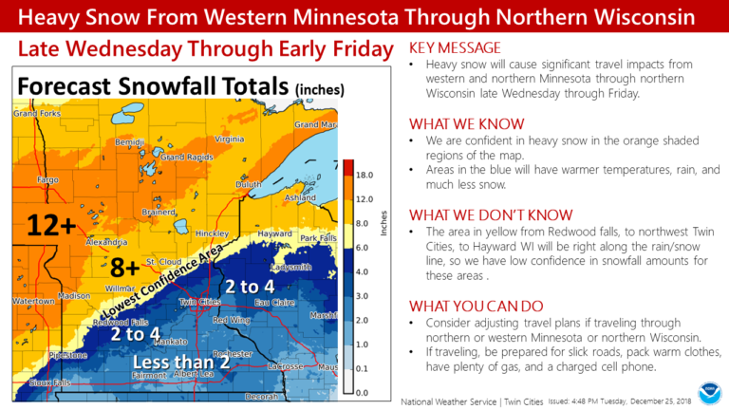
An example of how uncertainty can exist in winter storm
Forecasts. Areas sitting along the rain/snow line can be
Hard to predict what/how much precip they will receive.
However, it makes note that people should prepare in
In the situation that the worst possible case scenario
Happens.
https://www.google.com/search?q=weather+uncertainty+winter+storms&source=lnms&tbm=isch&sa=X&ved=0ahUKEwi83p7T0Z7hAhVCNd8KHXVNBbIQ_AUIDygC&biw=1047&bih=488#imgdii=J41pXbu_XACobM:&imgrc=_SvO3m7dsVDteM:

BUSINESS
Here is a summary of the 2017 figures for one store:
2017 Per One Store Figures | (Approximate $) Amounts
Net Sales | $16,911,254
Gross Profit | $4,519,312
Cost of Goods Sold | $12,391,941
Shipping Cost | $371,758
Inventory | $1,743,922
Spoilage Cost | $87,199
Shipping + Spoilage Costs | $458,957
Potential Savings on Spoilage | $8,078
Operating Expenses | $4,146,507
Labor Cost | $2,487,904
Potential Savings on Labor + Shipping | $2,488
Overall Potential Savings | $10,566

Our weather index is expected to save Weis around 1% more on labor and operating expenses and an additional 10% more on spoilage and shipping when comparing figures from 2017 10k report. Our weather index will inform Weis when hazardous weather conditions will occur, which will help tell when to close the store, stop transportation trucks, store food as needed, etc. Here are some factors we can minimize in order to increase the potential savings from 2017.
Labor
In order to increase our potential savings of labor, there are numerous factors we haven take into account. There will be increased amounts of staffing when productivity is increased through spending. We can make sure Weis is staffed at busy times such as weekends because that is when most people and families buy their groceries. We can also decrease the staffing at slow times such as late evening/overnight hours. Since Weis is open 24 hours, during those night hours people usually only come in for emergency supplies. Most often, people are not specifically in the store to buy their groceries . Our weather index provides information of what the weather outlook is going to be like for that week. Weis can take the weather into account and staff accordingly.
In Summary, we can decrease the cost of labor by understaffing when less staffing is necessary due to lack of consumer apparences during the night hours and at times when we know sales are going to be low. Our weather index can forecast the weather in advance to help Weis plan their laboring costs accordingly.
Food Spoilage
There are many factors to consider when looking to increase the potential savings from food spoilage. Weis should order a lot of what is bought everyday like milk, eggs, and bread. Weis should not order a lot of unnecessary goods, or products customers would only need during certain times of the year (seasonal foods) like soup, candy, ice cream, etc. Weis should also be cautious about the expiration date of the food they buy. If we know something is going to be on the shelf for a while, it is better to buy it with a longer expiration date so that this item will not spoil. Different foods have to be kept at different temperatures and we have to keep this in mind. We have to track customer purchases of prepared foods such as salad bars, hot foods, and bakery items. We have to be sure not too many of these items are made so that they will not be thrown out at the end of the day. Tracking the days these kinds of prepared foods are purchased and establishing a pattern of how much to make of each food and on each day should be considered. By using the index, Weis can see when there is hazardous weather coming and they have the ability to cancel the transportation of this food order so that these products will not spoil. This should help decrease the amount of money wasted in food spoilage.
Store Closings
Weis is open 24 hours. Some reasons why Weis managers would close Weis would be for majors holidays such as Christmas and only open half days on other holidays such as Thanksgiving. The reason Weis is open in the morning on major holidays such as Thanksgiving is because customers need last minute goods for their holiday events. Staying open until around 3pm could increase sales. Weis will stay open for storms because this will increase our sales tremendously. Customers run out before and during storms to stock up because they may not be able to get to the grocery store for a couple of days. Closing during the storm could help increase our profit in a way by decreasing the labor costs. Our index can help Weis by predicting the incoming weather so that they can make the call toon whether or not to close the store. As of now, Weis will stay open for storms, but closings may be essential during hazardous weather when consumers decide to stay home.
Weather Related Subjects
There are certain circumstances when the weather/seasons can heavily impact our goods sales and transportation costs. Weis needs to stock their inventory with certain foods based on the seasons and weather. In the summer, it would be wise to try to get a local farm for fresh fruits and vegetables. Customers buy foods for grilling, fresh fruit and vegetables, and lighter foods in the summer, so it would be best to overstock these specific items. In the fall, bakery items, tailgating foods, and game foods should be overstocked. In the winter, customers buy comfort and warm foods like soup, pasta, and ingredients for stew. Fruits and vegetables may be hard to get in the winter locally, so we have to keep this in mind and consider the cost of transportation to get these foods. Before an impending storm, the necessities such as milk, bread, and eggs should be over stocked. Customers will probably start coming in to stock up about one to two days before a storm.
In summary, weather has a huge impact on sales and what kind of foods to stock up on considering we are trying to minimize spoilage.
Transportation
Weis has to keep in mind the cost of transportation especially in the winter. Transporting goods in the winter can be hard considering the impact winter storms and freezing temperatures have on the roads. To minimize this cost, our index will be able to predict when there are winter storms coming so that Weis can improvise. It can also be hard to transport in the summer due to high temperatures causing food spoilage, this is where our index can come into help as well. Weis will know the weather in advance and how to prepare for it and minimize the cost of transportation and food spoilage.
Advertising
There are a lot of ways Weis can save money on advertising. Some newspapers have free weekly circulars that we can use to get the word out about Weis. These circulars are completely free and are advertised weekly. Getting a bigger sign for the front of the store can be helpful too. Customers walking or driving by are more apt to see the sign when it’s more in their faces. Even customers walking into the store already can see the specials advertised on the sign and can just walk in and buy immediately. A way our weather index can help with advertising is that the index will show when there is a storm or extreme weather will occur. Weis can then advertise their sales and products when there is a storm approaching to get more customers into the store buying their products.
Here is a potential summary of figures using our methods.

2017 Per One Store Figures | (Approximate $) Amounts
Net Sales | $16,911,254
Gross Profit | $4,519,312
Cost of Goods Sold | $12,391,941
Shipping Cost | $371,758
Inventory | $1,743,922
Spoilage Cost | $87,199
Shipping + Spoilage Costs | $458,957
Potential Savings on Spoilage + Shipping 10% | $45,896
Operating Expenses | $4,146,507
Labor Cost | $2,487,904
Potential Savings on Labor + Operating Expenses 1% | $66,344
Overall Potential Savings | $112,240

As noted in the chart, our potential savings would be $112,240 which is $101,674 more than the 2017 potential savings. Using our method would save Weis more than what they saved in 2017. Wind.X will help Weis save way more money than 2017 by forecasting extreme weather so Weis can plan out their labor, products, transportation, advertising, and store closings accordingly.
INDEX
What Is The Index
This index was designed specifically for Weis markets. This digital product will help the Store managers as well as department managers, or even shift managers, determine the weather conditions and how they will have an impact on business in the store such as consumer traffic, as well as transportation, pertaining to consumer travel to and from the store as well as delivery of produce and other goods to the store. This index looks at extreme weather conditions and how to save Weis the most amount of money that we can each year with regards to weather. Savings in certain areas are made clear in the following sections.
This index will be produced digitally and installed on one or a few of the computers in the store. The program has a direct link to our software which will feed new weather information in to create an easy to look at and understand design that will be useful for the managers to make easy and sometimes split second decisions. These will in turn save the company money.
Index Format
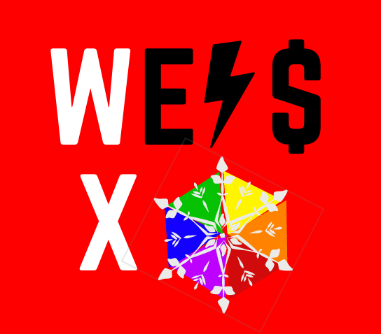
The program will be installed on the computer, to enter the program you will click this icon.
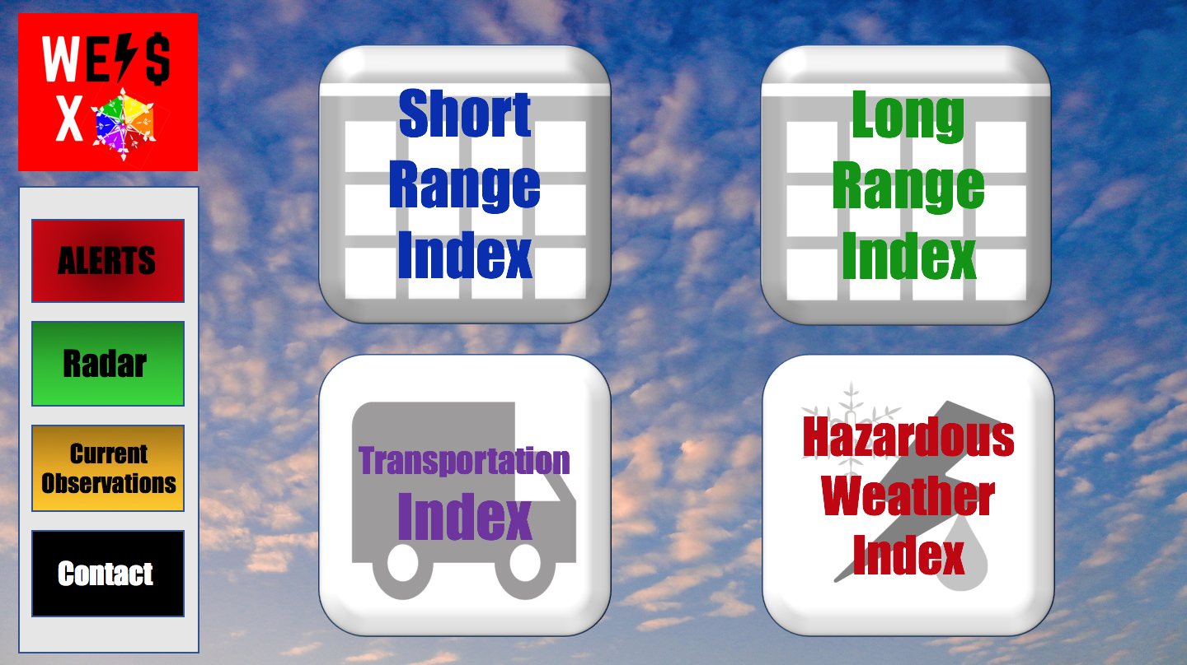
Once in the computer program the user will be shown a home screen (Shown Below). This home screen will allow the user to pick from a toolbar on the left side including Alerts, Radar, Current Observations, and a contact button. The alerts will take you to the current weather alerts for the store location and will automatically as the alerts are updated through the National Weather Service (NWS). The next option is a radar, this link is directly linked to a live radar for the state of Pennsylvania. Both of these tools can help to keep staff safe in different weather situations. Another link that could help is a current observation, this is also available on the left side. The current observation will be pulled from the closest airport sight to the store location. The observation is updated every hour and will include, temperature, wind chill temperature, dewpoint, weather conditions, and sky cover. The previous links are easily found on the internet but this is user friendly and is easy to find for a person not understanding how to find this type of information when they need it. Finally the contact button will allow the user to email or call us directly if any of the products malfunctions so we can quickly find the problem and make the fix.

The four large icons on the screen are the index products that we will update through the software directly to the stores program. These four icons include, a short range index that will go out 7 days, a long range outlook that will go out 30 days, a transportation index that will go out 10 days, and a hazardous weather index that will come out when impactful weather is set to move into the region. This index will be issued 12 hours prior to impactful weather and be an hourly forecast and index through the storm until the weather has moved out. This index is updated every 3 hours after being issued.
The Color Scale
This index and all of the four products use a color scale to show how impactful weather can be in each area of the the business. This color scale is formulated by our experts to show what kind of impacts certain weather conditions have on the business. These conditions are shown in the table below, along with amounts of rain, snow, and ice leading to the different levels of the index. Our coding program reads our forecast that we put out each morning and from that forecast the program determines which color to spit out for that day based on our color scale. This program will automatically insert the color that it determines is needed for that day or hour. Once each index is ran through the program, it sends that forecast directly to your computer in the store where you can view the updated forecast and index. The index will help to see things like consumer traffic in the store and also the amount of staff that should be on shift at a time, this can be determined from our index and consultation with the managers. The next thing the index will improve upon is transportation, this is either consumers travelling to the store or even Weis trucks and deliveries coming to the store or around in different areas of our transportation forecast. The color scale is broken down with the meaning of each color and weather factor scale in the table below.

Index Color | Index Meaning
GREEN | All Clear, no impactful weather is expected.  Normal staff schedule and deliveries.
YELLOW | Minor Impacts, This includes, dense fog, rain between 0.1-0.50 inches, ponding on roadways, or light snowfall of 1-3 inches or a glaze of ice accumulation.  Staff could be reduced by a few during this time, deliveries and transportation may go on with small delays.
ORANGE | Moderate Impacts, This includes, moderate rain between 0.50-2 inches, Ponding on the roadways, minor flooding, moderate snowfall between 3-8 inches, or 0.01-0.1 inches of ice accumulation.  Staff should be reduced, consumers will likely stay away during these hours cutting down business. Deliveries and transportation will be slow and could be difficult in some places. Think about postponing deliveries.
RED | High Impacts, This includes heavy rain between 2-3 inches, localized flooding, Heavy snowfall between 8-16 inches, or 0.1-0.25 inches of ice accumulation.  Staff should be reduced by about half, Consumers will mostly be in their homes as road conditions could deteriorate quickly. Some consumers may still try to make their way into the store, deliveries and transportation will be very difficult, trucks could get stranded and produce could be lost in the process, Cancel deliveries for the day and reschedule for 24-48 hours after the storm.
PURPLE | Extreme Impacts, Heavy rainfall greater than 3 inches, widespread flooding, Heavy snowfall greater than 16 inches, or greater than 0.25 inches of ice accumulation.  Staff should remain very few if the store remains open, consumers will also be very few if any, store could actually lose money if it stays open. Roadways will likely be flooded in areas or completely snow covered and getting worse. Deliveries should be cancelled and moved 24-48 hours after the storm had ended. When no consumers are in the store if it remains open try power saving on the lights and displays to cut down on power costs.

Short Range Forecast Index
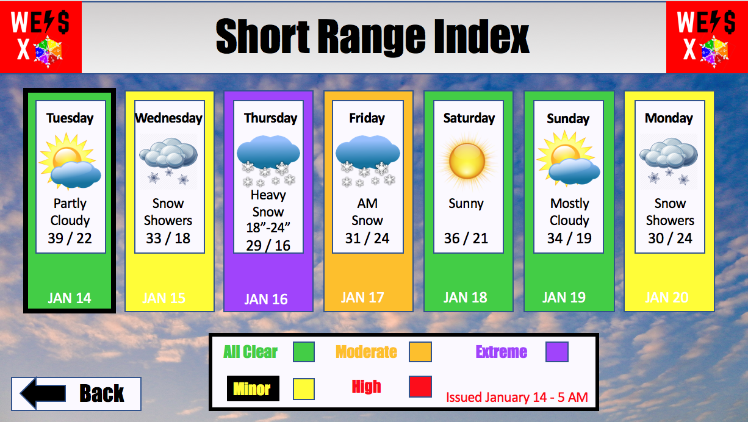
The short range index is a 7 day forecast and index for the store’s location. This index is updated each morning at 5 AM directly through the program as stated before. The color scale is used each day to show potential impacts that weather on any certain day will cause the store, the color scale is updated automatically when the forecast is implemented. Store managers can use this as a simple tools for decision making with regards to scheduling or even to contact deliveries or Weis trucking so they do not drive through something such as a massive snow storm shown on this sample index. The sample shows each day is labeled with day of week, date and also a weather forecast for the day, and it includes a forecast icon as well as a description. Temperatures are included in a high/low format. Any precipitation amounts that will have many impacts on the store are also shown (Example Thursday- 18”-24” of snow).

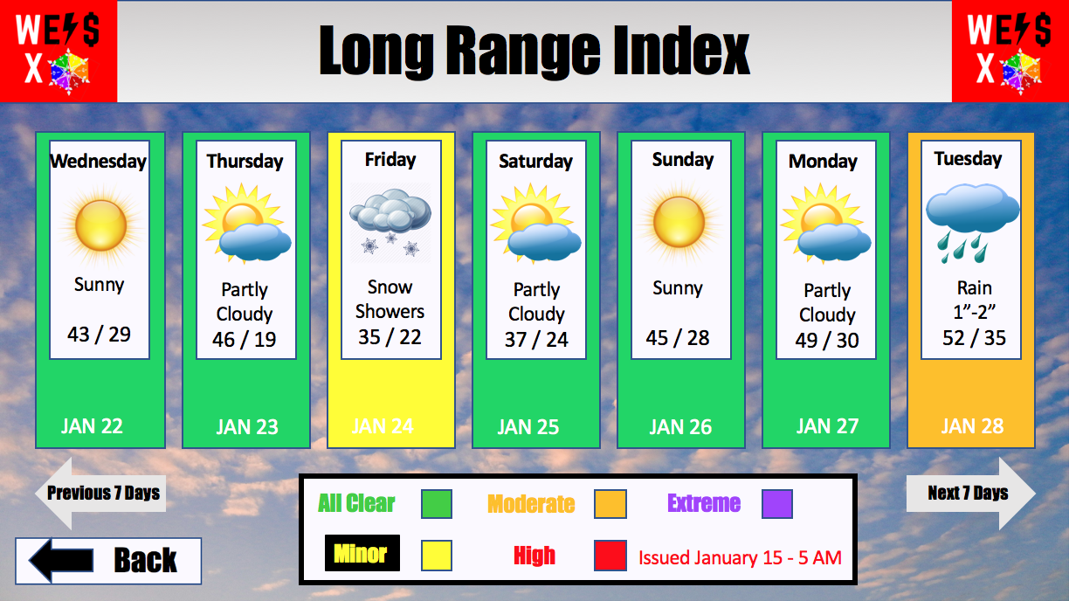
Long Range Forecast Index

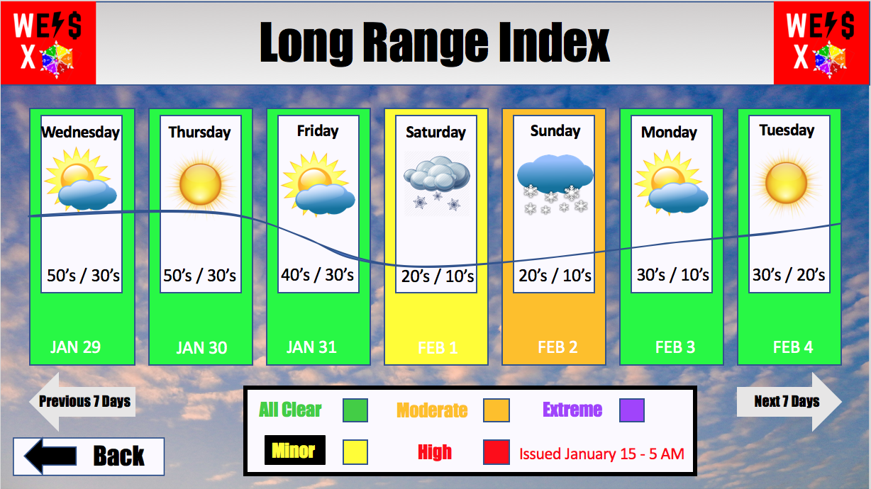
The long range index is in a 30 day format for the forecast and index. This format is updated on the 1st and the 15th of each month at 5 AM directly through the program. Each day still includes forecast graphics just like the short range index through day 14, after this the long range forecast goes towards the trends we are seeing in the long range outlooks. This will include a temperature trend line along with precip chances and this will then formulate a color through our specialized computer program just like every other day. That will run from day 15 to day 30 of the long range index.
The most important part is the index color each day. This goes by the same scale and will help managers to look into the next week or two and see if they need to keep an eye on certain dates for impactful weather that could hinder business. Impactful weather can be noticed farther out now with the advances in forecasting. The accuracy during the summer months is very high due to great forecasting tools for long range model data. The winter poses a challenge for long range forecasting because winter weather includes more factors than the warmer season. Cold weather mixing with warm weather causes a mixing of precipitation types and that is difficult to forecast after about 3-4 days out. This tool will be especially useful in the winter months, winter storms cause the most impacts to the store. The outlook will keep dates and in mind that managers can watch out for to plan accordingly for the store, which will ultimately save the store money.

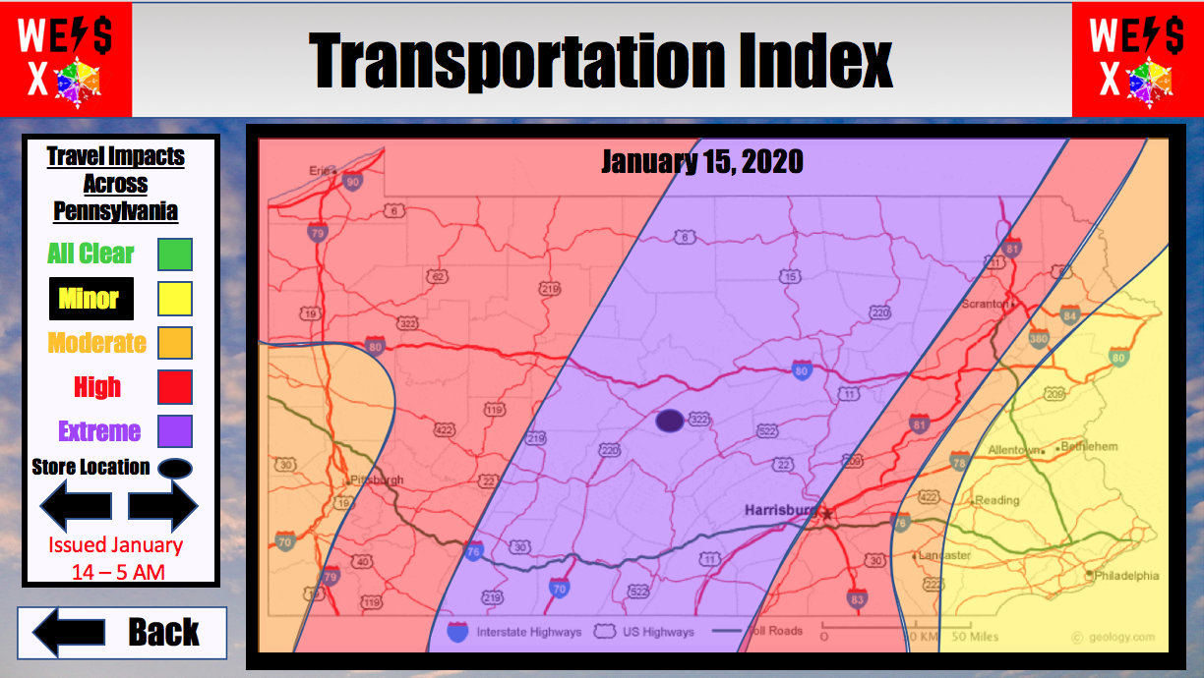
Transportation Index
The transportation forecast is in a different format than the short and long range index. This will show a daily look at the state of Pennsylvania with the store location shown. This index shows the same color scale that has been used in the previous two indexes. This time around the color scale on the index looks to show where in the state we may be dealing with issues. The color scale is produced the exact same way with the forecast we will update being fed into our program which will determine which areas of the map need to be shaded a certain color based on the data. The index above is for the sample index created in the short range forecast for January 15. This shows a massive snow storm hitting central Pennsylvania with impacts being felt throughout the state. The index will help the managers or logistics manager determine if travel will be safe for staff members to get into work as well as if deliveries can be made to the store. If conditions are bad travel should not be recommended.

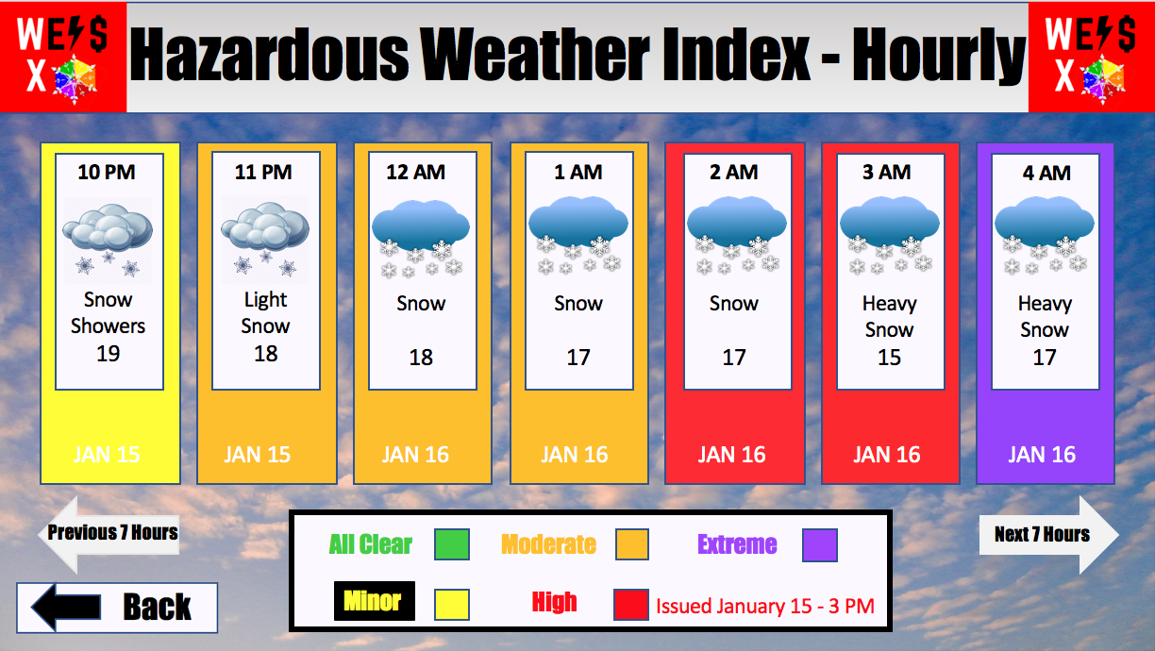
Hazardous Weather Index
The Hazardous weather index will be created and sent out when impactful weather is forecasted to occur in the area. The format of the index will be in an hourly format and will go out 24 hours from the time of the update. This index will be created 12 hours before the start of the event and be updated every three hours until the impactful weather event has concluded. This uses the same format as the short and long range forecast and same index scale, just in the hourly format. The color scale will also be updated every three hours with the new hourly forecast being run through our program to formulate the colors for each hour of the forecast you will see. This index will help to get employees home safely in the event of severe weather and also will become a very good scheduling tool when weather is impacting the area. For example, if the store were to close and need a time to reopen they can use this index. This can also help trucking and deliveries find good times before or after impactful weather to make the deliveries as needed by the Weis supermarkets.
Savings Created By The Index
Savings from our index will be an estimated value that our group of professionals believes this index could save Weis supermarkets. These savings will come from the use of the index and decision making of the managers with regards to the weather. Our experts believe this method will save Weis the most amount of money possible each year and will continue for years to come.
The savings are presented in the table below:

Weis Shipping Cost (2017) = | $371,758.00
Weis Spoilage Cost (2017) = | $87,199.00
Total 2017 Shipping + Spoilage = | $458,957.00
WindX 5% Savings on Shipping + Spoilage =  $458,957.00 x 0.05 = | $45,896.00
Weis Operating Expenses (2017) = | $4,146,507.00
Weis Labor Cost (2017) = | $2,146,507.00
Total 2017 Operating + Labor | $6,634,411.00
WindX 1% Savings on Operating + Labor =  $6,634,411.00 x 0.01 = | $66,344.11
WindX Overall Savings= | $112,240.11

CONTRACT
This Agreement (this “Agreement”) is made effective as of ________, between _______, of _______, _______, _______, ________ (“Seller”), and _______, of _______, _______, _______(“Buyer”).
- ITEMS PURCHASED. Seller agrees to sell, and Buyer agrees to buy, the following products (the “Goods”) in accordance with the terms and conditions of the Agreement.
Description Quantity Unit Price Total Price
Installation Fee Single Store $500
Wind.X Weis Index Single Store $50,000/yr. $50,500

2. SECONDARY ITEMS (OPTIONAL). Seller agrees to provide Goods to other stores, and Buyer agrees to buy, in the chain in accordance with the terms and conditions of the Agreement.
3. PRODUCT STANDARDS. The Goods shall comply with the Seller’s quotation dated _______ and incorporated into this Agreement by reference.
4. TITLE/RISK OF LOSS. The Goods shall be delivered F.O.B shipping point.
5. PAYMENT. Payment shall be made to _______, _______, _______, _______ on or before _______.
Payment terms are _______% discount within _______ days, net due _______ days from invoice date.
If any invoice is not paid when due, interest will be added to and payable on all overdue amounts at 0 percent per year, or the maximum percentage allowed under applicable law, whichever is less. Buyer shall pay all costs of collection, including without limitation, reasonable attorney fees.
In addition to any other right or remedy provided by law, if the Buyer fails to pay for the Goods when due, the Seller at its option may treat such failure to pay as a material breach of the Agreement and may cancel this Agreement and/or seek legal remedies.
6. DELIVERY. Time is of the essence in the performance of the Agreement. Seller will arrange for delivery by carrier chosen by Seller. Delivery shall be completed by _______.
7. PAYMENT OF TAXES. Buyer agrees to pay all taxes of every description, federal, state, and municipal, that arise as a result of this sale, excluding income taxes.
8 WARRANTIES. Seller warrants that the Goods shall be free of substantive defects in material and workmanship.
9 MISCELLANEOUS. Buyer agrees to respect the Uniform Commercial code in compliance with company seller conditions. Seller agrees to maintain confidentiality between the buyer and seller agreement (a.k.a Wind.X tailors specifically to Weis Markets and will not distribute program information to any other competitor). Breach of contract will be resolved in court expenditures both by buyer and seller in faulty action of contract agreements
In compliance of agreement execution by both Parties in duplicate on the Signing Date.

Wind.X Co.

________________________ Date: _______________
Jordyn Kosienski (Manager)

________________________ Date: _______________
Hannah Evans (Industry Representative)

________________________ Date: _______________
Laura Silver (Meteorologist)

________________________ Date: _______________
Matt Yarosewick (Model Developer)

In compliance of agreement execution by both Parties in duplicate on the Signing Date.
Weis Markets

________________________ Date: _______________
Managing Director

________________________ Date: _______________
Sales Director

________________________ Date: _______________
Advertising Director

________________________ Date: _______________
Director of transportation

Sources Cited
Borenstein, Seth. “Weather Forecasts Have Gotten Better, Believe It or Not.” Lehigh Valley Business Cycle, 19 Mar. 2019, www.mcall.com/business/mc-weather-forecasts-improvement-20170602-story.html.
Center, National Hurricane. “National Hurricane Center.” National Hurricane Center, 1 Jan. 2001, www.nhc.noaa.gov/.
“National Oceanic and Atmospheric Administration.” National Oceanic and Atmospheric Administration, www.noaa.gov/.
WEIS MARKETS, INC 2017 ANNUAL REPORT ON FORM 10-K, www.sec.gov/Archives/edgar/data/105418/000010541818000006/wmk-20171230x10k.htm.
“{{ $State.current.data.title | Translate }}.” Storm Advisory Watch - Most Weis Markets' Stores Have Closed Due to Weather-Will Reopen on Sunday at 9AM. | Weis Markets, www.weismarkets.com/storm-advisory-watch-most-weis-markets-stores-have-closed-due-weather-will-reopen-sunday-9am.

